Day 3
Peripheral Troubleshooting Theory:- Common issues and solution for peripherals.
1.List 5 common issues users face with USB keyboards or mice on laptops, and write one possible solution for each.
5 Common Problems with USB Keyboard or Mouse on a Laptop
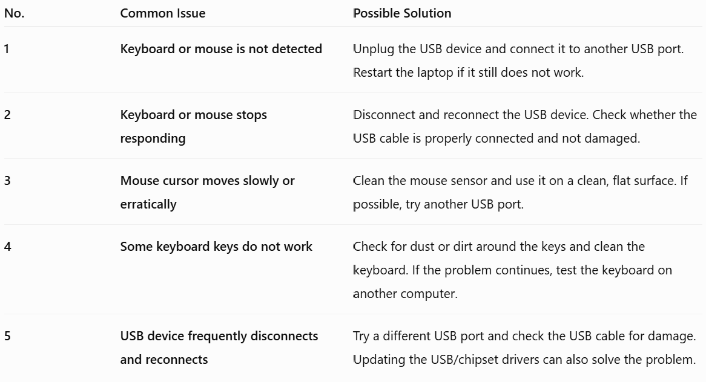
In short:
USB keyboard/mouse problems are commonly caused by loose connections, faulty USB ports, damaged cables, dirty sensors/keys, or driver problems.

2.Simulate a troubleshooting flow: Your Bluetooth headphones are not connecting to your phone. Write the exact step-by-step actions you would take to diagnose and fix the issue, mentioning any settings or indicators you would check.
Bluetooth Headphones Not Connecting to Phone — Troubleshooting Flow
If my Bluetooth headphones are not connecting to my phone, I would troubleshoot them in the following order:
Step 1: Check the headphones
- Make sure the headphones are switched ON.
- Check the battery level. If the battery is low, charge them for a few minutes.
- Look at the LED indicator:
  - Flashing blue/white → usually means the headphones are in pairing mode.
  - Solid light → may indicate that they are already connected to another device or not in pairing mode.
- If necessary, press and hold the Power/Bluetooth button to enter pairing mode.
Step 2: Check Bluetooth on the phone
- Open Settings → Bluetooth (the exact menu name may vary by phone).
- Make sure Bluetooth is ON.
- Check whether the headphones appear under Available devices or Other devices.
Step 3: Try connecting
- Tap the name of the headphones.
- Wait for the status to change to Connected.
- If a PIN/passcode is requested, enter the code provided by the headphone manufacturer, commonly 0000 or 1234 for some older devices.
Step 4: If the headphones appear but will not connect
- Tap the gear/settings icon next to the headphone name.
- Select Forget/Unpair this device.
- Turn Bluetooth OFF, wait a few seconds, and turn it ON again.
- Put the headphones back into pairing mode.
- Search for the headphones again and try pairing.
Step 5: Check whether they are connected to another device
- Turn Bluetooth OFF on nearby devices such as a laptop, tablet, or another phone.
- Some headphones automatically reconnect to the last device they used.
- Then put the headphones into pairing mode and try connecting to the phone again.
Step 6: Restart both devices
- Restart the phone.
- Turn the headphones OFF and ON again.
- Enable Bluetooth on the phone and try pairing again.
Step 7: Check the Bluetooth distance
- Keep the headphones close to the phone, preferably within 1–2 metres during troubleshooting.
- Move away from possible sources of interference and try again.

Step 8: Reset the headphones
If they still do not connect:
- Perform a factory/Bluetooth reset using the headphone manufacturer's instructions.
- After resetting, the headphones should normally enter pairing mode.
- Search for them again under Settings → Bluetooth.
Step 9: Identify where the fault is
I would test the headphones with another phone.
- They connect to another phone: The problem is probably with the original phone's Bluetooth settings/software.
- They do not connect to another phone: The problem is likely with the headphones.
Step 10: Final checks
If the problem is with the phone:
- Check for a system/software update.
- If available, use Settings → System → Reset options → Reset Wi-Fi/Bluetooth/network settings.
This may remove saved Wi-Fi networks and Bluetooth pairings.
If the headphones still fail after resetting and testing with another device, they may have a hardware or battery fault and may need servicing.

Simple Troubleshooting Flow
Headphones ON?
↓
Battery charged? → No → Charge headphones
↓ Yes
Bluetooth ON on phone? → No → Turn Bluetooth ON
↓ Yes
Headphones in pairing mode? → No → Enter pairing mode
↓ Yes
Headphones visible in Available Devices? → No → Restart Bluetooth + headphones
↓ Yes
Connect successfully? → No → Forget device → Pair again
↓
Still not connecting? → Disconnect other devices → Restart phone/headphones → Reset headphones
↓
Test with another phone → Determines whether the problem is with the phone or headphones.

3.A user reports that their external webcam is not detected during a Zoom call on Windows 10. Write a checklist of 6 things to check or try to resolve the problem.
Checklist: External Webcam Not Detected in Zoom on Windows 10
A user can follow these 6 checks in order:
- Check the USB connection
  - Make sure the webcam is firmly connected to the laptop's USB port.
  - Try a different USB port.
  - Check whether the webcam's indicator light turns on.
- Check Device Manager
  - Right-click Start → Device Manager.
  - Expand Cameras, Imaging devices, or Sound, video and game controllers.
  - Check whether the webcam appears.
  - If there is a warning symbol, update or reinstall the webcam driver.
- Check Windows camera privacy settings
  - Go to Settings → Privacy → Camera.
  - Make sure Allow access to the camera on this device is ON.
  - Turn ON Allow apps to access your camera.
- Allow desktop apps to use the camera
  - In Settings → Privacy → Camera, find Allow desktop apps to access your camera.
  - Make sure it is ON, because Zoom is a desktop application.
- Select the correct camera in Zoom
  - Open Zoom → Settings → Video.
  - Under Camera, check the camera drop-down list.
  - Select the external webcam instead of the laptop's built-in camera.
  - Check whether the video preview appears.
- Restart and test the webcam
  - Close Zoom completely.
  - Disconnect and reconnect the webcam.
  - Restart the computer and open Zoom again.
  - If it still does not work, test the webcam in another application such as the Windows Camera app to determine whether the problem is with the webcam or Zoom.
Quick diagnosis
Webcam not visible in Device Manager → likely USB/driver/device problem.
Webcam visible but blocked in Windows → check privacy settings.
Webcam works in Windows but not Zoom → check Zoom's camera selection and permissions.

4.You are helping a friend whose printer is showing 'offline' status on their PC. Describe how you would use the Windows Troubleshooter tool to try to fix the issue, and explain what information the tool provides during the process.
Using Windows Troubleshooter to Fix a Printer Showing “Offline”
If my friend's printer shows “Offline” on the PC, I would use the Windows Printer Troubleshooter as follows:
Step-by-Step Procedure
1. Check the basic connection
- First, make sure the printer is powered ON.
- Check the USB cable or make sure the printer and PC are connected to the same Wi-Fi network.
2. Open Windows Settings
- Click Start → Settings.
- Go to Update & Security → Troubleshoot.
- Select Additional troubleshooters.
3. Start the Printer Troubleshooter
- Select Printer.
- Click Run the troubleshooter.
- Windows will automatically begin checking the printer.
4. Select the affected printer
- If more than one printer is installed, Windows may ask which printer has the problem.
- Select the printer that is showing Offline.
5. Allow Windows to diagnose the problem
The Troubleshooter checks common problems such as:
- Printer connection and communication.
- Incorrect printer settings.
- Printer being set as offline.
- Driver-related problems.
- Print spooler/service problems.
- Default printer configuration.
6. Follow the recommended fix
- Windows will display the problems it finds and may offer options such as Apply this fix, restart a service, change a setting, or set the printer as the default printer.
- Follow the on-screen instructions and allow Windows to apply the recommended solution.
7. Test the printer
- After troubleshooting is complete, go to Control Panel → Devices and Printers or Settings → Devices → Printers & scanners.
- Check whether the printer status has changed from Offline to Ready/Online.
- Print a test page to confirm that the problem has been resolved.
What Information Does the Troubleshooter Provide?
During the process, the Windows Troubleshooter provides information about:
- Problems detected — identifies possible causes of the printer problem.
- Diagnostic results — tells whether a particular setting, connection, or service is causing the issue.
- Recommended actions — suggests what should be changed or repaired.
- Fixes applied — indicates which problems Windows was able to automatically correct.
- Problems that could not be fixed — tells the user if manual troubleshooting is still required.
Simple Flow
Printer Offline
↓
Settings → Update & Security → Troubleshoot
↓
Additional troubleshooters → Printer
↓
Run the troubleshooter
↓
Select printer
↓
Windows checks connection, settings, drivers and services
↓
Apply recommended fix
↓
Print a test page
↓
✅ Printer Online and Working

